NAAN MUDHALVAN

TEAM LEADER :M.Nivetha(backend developer)
E-MAIL ID :nivetha23032007@gmail.com
TEAM ID :SWTID-2026-1768
TEAM MEMBER:
Name Mail-ID Role
A.Thanisha thanisha2007at@gmail.com (demo video maker)
P.Vishnupriya sanjeevipriya36@gmail.com (document)
M.Nirmala nishanirmal1121@gmail.com (document)
C.Kaviya pioc67789@gmail.com (document)

Spend Wise
Project title
Spendwise is a sample Backend Learning Project using Node.js, Express, MongoDB, and JWT.

Project Overview
SpendWise is a backend application designed to help beginner developers learn how to build secure REST APIs using Node.js, Express, MongoDB, and JWT authentication. The project focuses on implementing user authentication and basic CRUD operations.

Key Objectives:
- Provide secure user authentication using JWT
- Demonstrate MongoDB integration using Mongodb compass
- Show how protected routes work using middlewa
Target Users:
- Beginner backend developers
- Students learning Node.js and Express
- Anyone who wants a simple project to understand JWT and MongoDB
- Learners who want hands-on practice with REST APIs

Instruction:
SpendWise is a backend-only project built using Node.js and Express.

Start:
npm init
npm install
npm run dev

Steps to Create the Project:

- Choose or create a directory for the backend project.
- Open terminal and navigate to that directory.
- Initialize Node.js project using npm init.
- Install required packages: express, mongoose, jsonwebtoken, bcrypt, cors, dotenv.
- Create folders: models, routes, controllers, middleware, config.
- Start the server using npm run dev.
- Test APIs using Thunder Client at http://localhost:5000.

Pre-requisites: Software Requirements
- Node.js
- MongoDB
- npm
- Git
- Code editor

Knowledge Requirements
- JavaScript
- Node.js and Express.js
- MongoDB
- JWT authentication
- Basic API concepts
- Git basics

Project Architecture
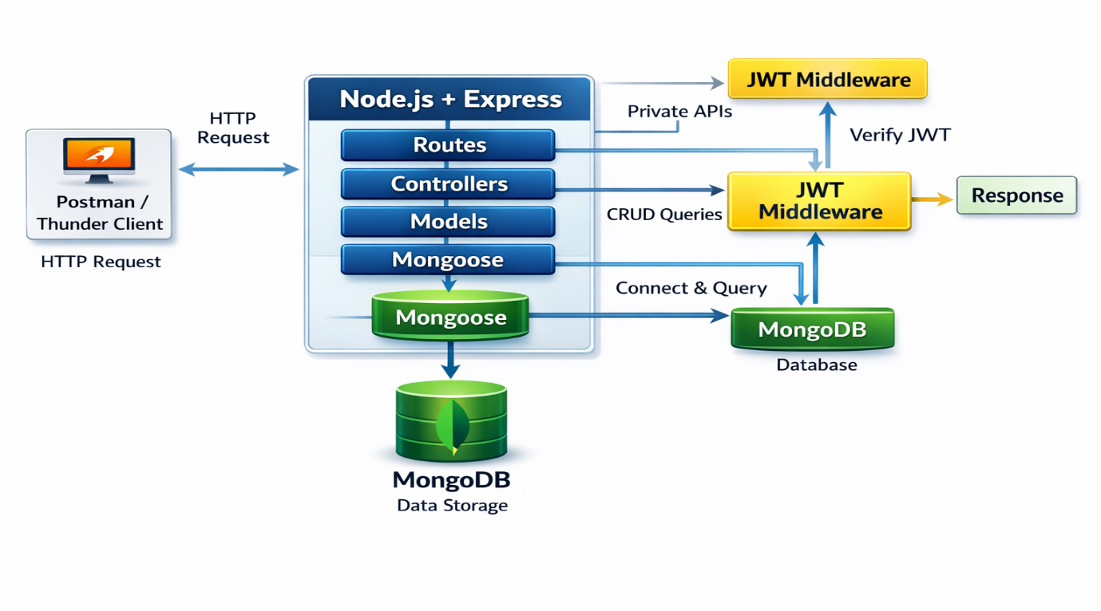

Technical Architecture
- Controllers: Handle business logic for authentication and CRUD
- Routes: API endpoints for auth and CRUD operations
- Middleware: JWT verification and request protection
- Configuration: Database connection and environment variables

Features
User Authentication | JWT-based registration and login
CRUD Operations | Create, Read, Update, Delete transactions
Protected Routes | Secure APIs using JWT middleware
MongoDB Integration | Store and fetch data using Mongoose
Roles
- Write backend code
- Create APIs
- Test APIs using Thunder Client
- Push code to GitHub
System
- Authenticate users using JWT
- Handle CRUD operations
- Store and fetch data from MongoDB
- Protect private routes

Users Flow: 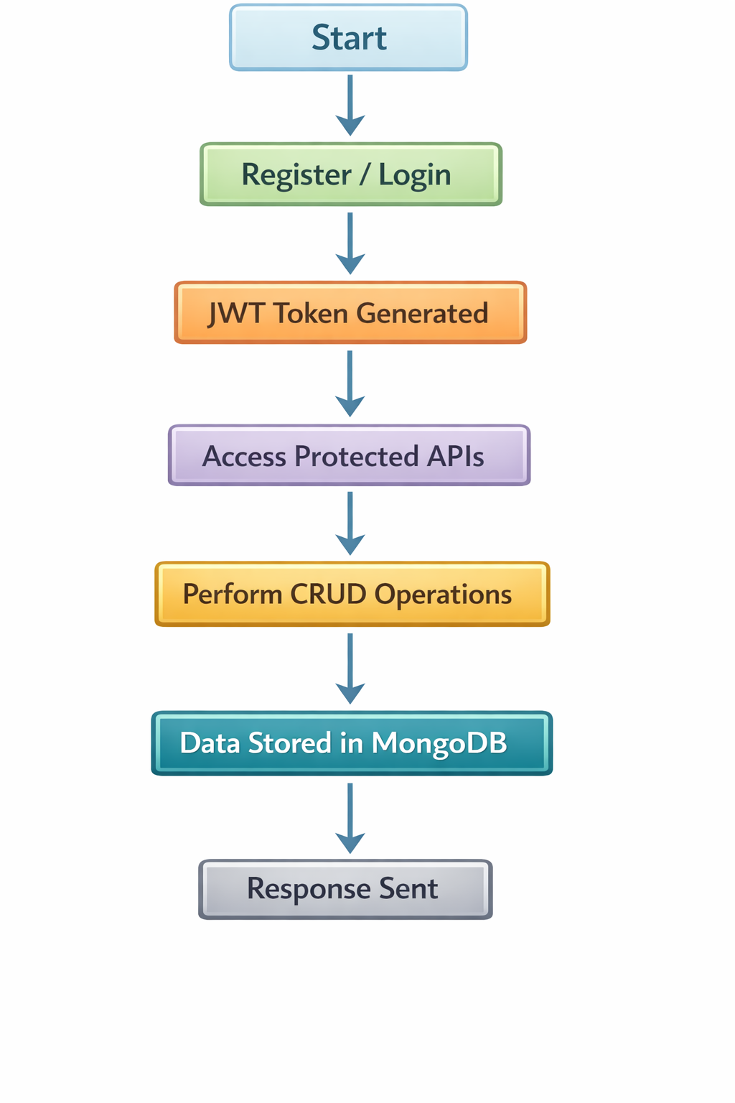
PROJECT SETUP
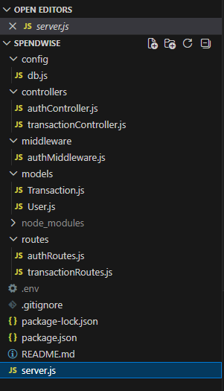
Project Setup
1. Install required tools:
- Node.js
- MongoDB
2. Create project folders:
- server folders (models, routes, controllers, middleware, config)

3. Install Backend Packages:
- Express
- Mongoose
- Jsonwebtoken

BACKEND DEVELOPMENT
- Setup Express server
- Create server.js file
- Create .env file and define PORT and DB URL
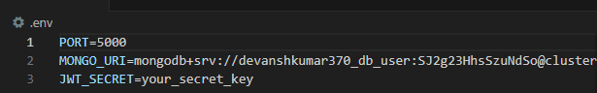
- Configure middleware (cors, express.json)
- User Authentication:
  - Create Register and Login routes
  - Generate JWT token
  - Protect routes using middleware

- Define API Routes:
  - Auth routes
Create Models
User Model:
- Name
- email
- password
PROJECT EXECUTION

Project Execution Steps:
- Start MongoDB
- Run backend server
- Test Register API
- Test Login API
- Copy JWT token
- Perform Create, Read, Update, Delete operations

Project Demo Video
https://drive.google.com/file/d/1HX75ftR17gqyRSfxtmLbRwzsMNpxPMJP/view?usp=drivesdk

